**Project plan**

# What is being done?

In this project I will make a mastermind game where the player has to guess the four-digit code and the guessing will be between 6 to 8 guesses, however to win the game the player has at least to have 4 or less guesses.

# Menu Options

When the game starts the player will choose between playing the game or see the instructions given on how to play the game.

# User interface

Inspiration to the user interface is as described below:

For each digit that is in the code and is located in the right position the player gets “+” but if the digit is found in the code but not in the right position, the player gets”-”. The 4-digit code which I think of consists of one odd number and three even numbers from a range of 1 to 6.

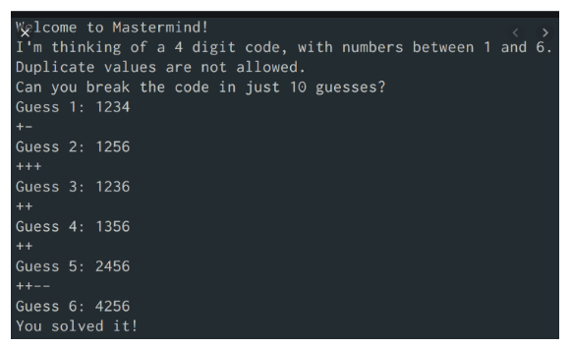

# Data structure

The will be a variable wherein the number of guesses is to be stored. And the right code will be stored in a list.